Development of Robust Algorithm for Imperceptible Watermarking in AI-Generated Content
First Author: Shruti Shreya Second Author: Mona Kumari Third Author: Dr. G. S. Mitra Thakur
Eamil id: shrutishreya5720@gmail.com Eamil id: monikabokaro2003@gmail.com Eamil id: gour.mitrathakur@bcrec.ac.in

Abstract— This project addresses the challenge of securing digital and AI-generated images against unauthorized use, tampering, and copyright violations. The objective is to develop an imperceptible and robust watermarking system for reliable image authentication. A hybrid DWT–DCT based approach with adaptive embedding and multi-objective optimization (NSGA-II) is used to embed watermark information in the frequency domain. The system is tested under various attacks such as compression, noise, scaling, and rotation to evaluate its performance. Experimental results show high image quality (PSNR > 40 dB) along with strong robustness and accurate watermark recovery. The proposed method provides an effective solution for digital rights management and AI-content authentication.

Keywords: DWT-DCT, Digital Image Watermarking, NSGA-II, Robustness, Image authentication.

Introduction

Digital multimedia content has become an essential component of modern communication systems due to the rapid growth of the internet and data-sharing technologies. However, the ease of copying, modifying, and distributing digital media has raised serious concerns regarding copyright protection, ownership authentication, and data integrity. To address these challenges, digital watermarking has been widely adopted as an effective technique for embedding hidden information into multimedia data in a secure and imperceptible manner.
Watermarking techniques can be broadly classified into spatial-domain and transform-domain methods. Among these, transform-domain approaches offer better robustness against common signal processing operations and attacks. In particular, the combination of Discrete Wavelet Transform (DWT) and Discrete Cosine Transform (DCT) has proven to be highly effective. DWT provides multi-resolution decomposition of the image into different frequency sub-bands, while DCT concentrates signal energy into a small number of coefficients, enabling efficient and robust watermark embedding.
One of the major challenges in watermarking is achieving an optimal balance between imperceptibility and robustness. Increasing the embedding strength enhances resistance against attacks but may degrade the visual quality of the host image. Conversely, reducing embedding strength preserves image quality but weakens the watermark. Therefore, selecting optimal embedding parameters is a critical task. In this context, Non-dominated Sorting Genetic Algorithm II (NSGA-II) is employed as a multi-objective optimization technique to determine suitable embedding parameters. It effectively handles conflicting objectives by generating a set of Pareto-optimal solutions.
In this work, a robust hybrid watermarking scheme based on DWT and DCT is proposed, where the watermark is embedded into selected frequency components of the image. To enhance robustness, watermark information is distributed across multiple sub-bands and coefficients. Additionally, redundancy and majority voting strategies are incorporated during the extraction process to improve resistance against various image processing attacks.
The performance of the proposed system is evaluated using standard metrics such as Peak Signal-to-Noise Ratio (PSNR), Structural Similarity Index (SSIM), and Normalized Correlation (NC). Furthermore, the robustness of the watermark is tested under different attack scenarios, including noise addition, compression, blurring, and resizing.
The proposed approach aims to provide a reliable and efficient solution for digital copyright protection and authentication, while maintaining high image quality and strong resistance to attacks.
The remainder of this paper is organized as follows: Section II reviews the relevant literature in digital watermarking; Section III details the proposed hybrid methodology and the NSGA-II optimization process; Section IV presents the experimental results and performance analysis; and Section V concludes the paper with an outlook on future enhancements.

Literature Survey

This literature survey reviews the milestones in digital watermarking that inform the proposed hybrid framework. The protection of intellectual property in digital media has transitioned from simple spatial techniques to complex transform-domain and optimization-based strategies.
Early watermarking techniques were primarily based on spatial-domain methods, where watermark information is directly embedded into pixel values. Although these methods are simple and computationally efficient, they are highly vulnerable to common image processing operations such as noise addition, filtering, and compression. To overcome these limitations, researchers have focused on transform-domain techniques, which provide better resistance to attacks.
Among transform-domain approaches, the Discrete Cosine Transform (DCT) has been widely used due to its strong energy compaction properties and compatibility with compression standards such as JPEG. DCT-based watermarking schemes embed watermark information into mid-frequency coefficients to achieve a balance between imperceptibility and robustness. However, these methods may still suffer from limited resistance to geometric distortions.
To further enhance performance, the Discrete Wavelet Transform (DWT) has been introduced in watermarking systems. DWT decomposes the image into multiple sub-bands, enabling multi-resolution analysis. Watermarks embedded in higher-frequency bands offer improved robustness against compression, while embedding in lower-frequency bands provides better resistance to noise. Despite these advantages, single-transform methods often fail to achieve optimal performance under diverse attack conditions.
Recent studies have explored hybrid approaches that combine multiple transforms to leverage their individual strengths. In particular, DWT–DCT based watermarking techniques have gained significant attention. In these methods, DWT is first applied to decompose the image, followed by DCT on selected sub-bands to embed the watermark. This hybrid approach improves both imperceptibility and robustness compared to standalone methods. However, the effectiveness of such systems largely depends on the selection of embedding parameters.
Another important research direction involves the use of optimization algorithms to determine optimal embedding parameters. Traditional methods often rely on manual parameter selection, which may not provide the best performance across different images and attack scenarios. To address this issue, evolutionary algorithms such as Non-dominated Sorting Genetic Algorithm II (NSGA-II) have been applied in watermarking. NSGA-II is a multi-objective optimization technique that can simultaneously optimize conflicting objectives such as image quality and watermark robustness. It generates a set of Pareto-optimal solutions, allowing the selection of parameters that provide a suitable trade-off.
Furthermore, several studies have incorporated redundancy and error correction techniques to improve robustness. Methods such as repeated embedding, majority voting, and multi-coefficient embedding have been shown to enhance watermark recovery under severe attack conditions. These approaches reduce the impact of noise and distortions by distributing watermark information across different regions of the image.
Despite significant progress, existing watermarking techniques still face challenges in maintaining high robustness against multiple simultaneous attacks while preserving image quality. Therefore, there is a need for advanced hybrid and optimization-based approaches that can adaptively balance these conflicting requirements.

Methodology

The proposed watermarking system is based on a hybrid transform-domain approach that integrates the Discrete Wavelet Transform (DWT) and Discrete Cosine Transform (DCT), along with multi-objective optimization using Non-dominated Sorting Genetic Algorithm II (NSGA-II). The objective is to achieve a balance between imperceptibility and robustness by optimizing embedding parameters and distributing watermark information across multiple frequency components.

1. Pre-processing

The input host image $I(x,y)$ and the watermarking image $W\left(x,y\right)$ are first preprocessed. The host image is converted to grayscale and resized to ensure even dimensions for proper transform operations. The watermarking is resized and converted into binary format:
$$W_{b}\left(x,y\right)=\left\{\begin{aligned}1, W(x,y ≥T \\ -1, otherwise\end{aligned}\right.$$
Where T is the threshold value.

2. DWT Decomposition

The input image is decomposed using 2D DWT into four sub-bands:
$$\left\{LL,LH,HL,HH\right\}=DWT(I)$$

- LL: Approximation component
- LH,HL,HH: Detail components

In this work, watermark embedding is performed in LH, HL and HH sub-band to ensure robustness and imperceptibility.

- Block-based DCT Transformation

Blockchain ensures
Each selected sub-band is divided into non-overlapping blocks of size 8x8. The 2D DCT is applied to each block:
$$D\left(u,v\right)=\frac{1}{4}C\left(u\right)C\left(v\right)\sum_{x=0}^{7}{\sum_{y=0}^{7}{f\left(x,y\right)\cos\left[\frac{\left(2x+1\right)uπ}{16}\right]}}\cos\left[\frac{\left(2y+1\right)vπ}{16}\right]$$
Where:
$$C\left(u\right)=\left\{\begin{aligned}\frac{1}{\sqrt{2}}, u=0 \\ 1, u≠0\end{aligned}\right.$$

4. Watermark Embedding

The watermark is embedded into selected mid-frequency DCT coefficients. The modified coefficients are given by:
$$D^{'}\left(u,v\right)=D\left(u,v\right)+α.W_{b}\left(x,y\right)$$
$$D^{"}\left(u,v\right)=D\left(u,v\right)+β.W_{b}\left(x,y\right)$$
Where:
- $α:$embedding strength for coefficient (4,4)
- $β:$ embedding strength for coefficient (3,3) and (5,5)
Thus, embedding is performed as:
$$D_{4,4}^{'}=D_{4,4}+α.W_{b}$$
$$D_{3,3}^{'}=D_{3,3}+β.W_{b}$$
$$D_{5,5}^{'}=D_{5,5}+β.W_{b}$$
After modification, inverse DCT is applied:
$$f^{'}\left(x,y\right)=IDCT(D^{'})$$

5. Image Reconstruction

The modified sub-bands are combined using inverse DWT to obtain the watermarked image:
$$I_{w}=IDWT(LL,{LH}^{'},{HL}^{'},HH)$$

6. Watermark Extraction

At the receiver side, DWT and DCT are applied similarly. The watermark is extracted by comparing original and watermarked coefficients:
$$∆\left(u,v\right)=D_{w}\left(u,v\right)-D_{o}\left(u,v\right)$$
The extracted watermark bit is determined as:
$$W^{'}\left(x,y\right)=\left\{\begin{aligned}1, ∆\left(u,v\right)≥0 \\ -1, otherwise\end{aligned}\right.$$

7. Majority Voting Scheme

To improve robustness, watermark bits are extracted from multiple coefficients:
$$W^{'}\left(x,y\right)=sign\left(\sum_{k=1}^{n}{∆_{k}}\right)$$
Where n represent the number of coefficients used for voting

8. Optimization Using NSGA-II

To embedding parameter $α \& β$ are optimized using NSGA-II. The optimization objectives are defined as:
- Imperceptibility (maximize PSNR)
$$PSNR={10 log}_{10}\left(\frac{{255}^{2}}{MSE}\right)$$
$$MSE=\frac{1}{MN}\sum_{x=1}^{M}{\sum_{y=1}^{N}{{\left[I\left(x,y\right)-I_{w}\left(x,y\right)\right]}^{2}}}$$

- Structural Similarity (SSIM)
$$SSIM=\frac{\left(2μ_{I}μ_{I_{w}}+C_{1}\right)\left(2σ_{II_{w}}+C_{2}\right)}{\left(μ_{I}^{2}+μ_{I_{w}}^{2}+C_{1}\right)\left(σ_{I}^{2}+σ_{I_{w}}^{2}+C_{2}\right)}$$

- Robustness (Normalized Correlation)
$$NC=\frac{\sum{W\left(x,y\right).}W^{'}(x,y)}{\sqrt{\sum{{W(x,y)}^{2}.\sum{{W^{'}(x,y)}^{2}}}}}$$

- Multi-objective Optimization Function
The objective vector is defined as:
$$F=[-PSNR, -SSIM, -NC]$$
NSGA-II minimizes F to obtain optimal values of $α \& β.$
- Attack Modeling
The robustness of the watermark is evaluated under different attacks:
$$I_{a}=I_{w}+N(x,y)$$
Where N(x,y) represents noise or distortion introduced by attacks such as:
- Gaussian noise
- JPEG compression
- Blurring
- Resizing
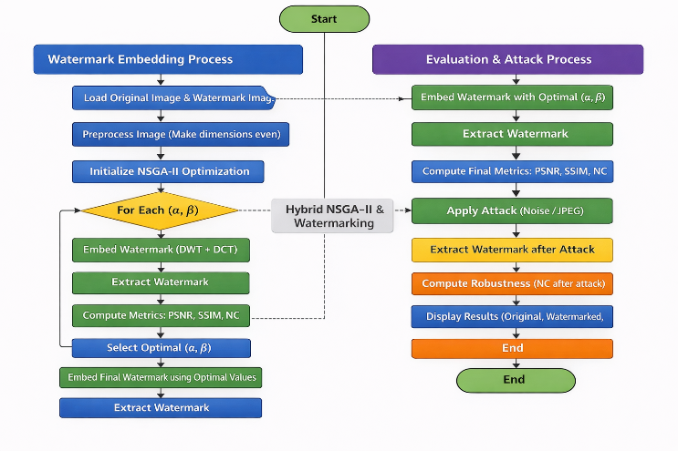
Fig.1.Flow chart of watermarking system

Pseudocode of the Proposed Work
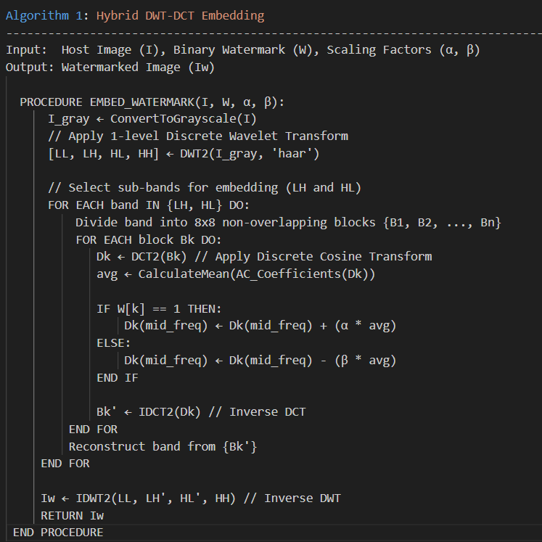

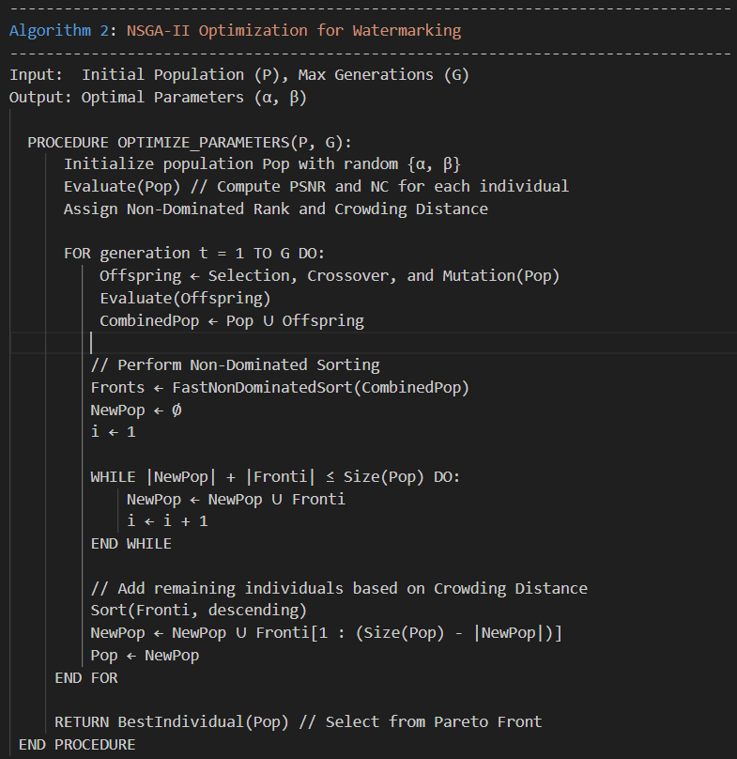

Result & Analysis
The performance of the proposed hybrid DWT-DCT watermarking algorithm was evaluated using standard grayscale test images of size 512x512. The primary evaluation metrics utilized are the Peak Signal-to-Noise Ratio (PSNR) for measuring visual quality and the Normalized Correlation (NC) for assessing watermark robustness.

Imperceptibility Analysis
Imperceptibility refers to the ability of the watermarking scheme to preserve the visual quality of the host image after embedding. In this work, imperceptibility is evaluated using PSNR and SSIM.
The obtained PSNR value of the watermarked image is approximately 44.04416868040994 dB, indicating that the distortion introduced by watermark embedding is negligible and visually imperceptible. Additionally, the SSIM value is observed to be around 0.9788641098003691, which confirms that the structural similarity between the original and watermarked images is very high.
These results indicate that the embedding process does not significantly degrade image quality, making the watermark invisible to the human visual system.
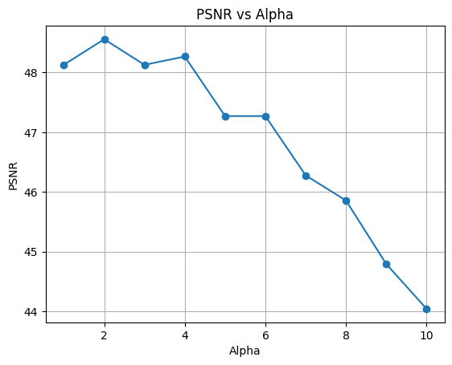
Fig.2. Variation of PSNR with embedding strength parameter α

Robustness Analysis
Robustness measures the ability of the watermark to resist various attacks and still be correctly extracted. The Normalized Correlation (NC) metric is used to evaluate watermark recovery accuracy.
Under no attack conditions, the extracted watermark achieves an NC value of approximately 0.9976989, which indicates almost perfect recovery. This demonstrates that the embedding and extraction processes are highly reliable.
To further evaluate robustness, the watermarked image was subjected to different types of attacks, including: Gaussian noise, JPEG compression, Blurring and Resizing.
The results show that the watermark remains detectable even after these distortions. In particular, the NC value after a Gaussian noise attack is observed to be around 0.34–0.75, depending on the embedding parameters and optimization settings. Although noise significantly affects the watermark, the use of redundancy and majority voting improves recovery performance.

Effect of NSGA-II Optimization
The integration of Non-dominated Sorting Genetic Algorithm II (NSGA-II) plays a critical role in optimizing the embedding parameters $α$and $β$. The algorithm generates a set of Pareto-optimal solutions that balance conflicting objectives such as image quality and robustness.
The optimized parameters obtained in this work are approximately:
$$α≈11.24460973134434,$$
$$β≈6.957221095059054$$
These values provide an effective trade-off between imperceptibility and robustness.
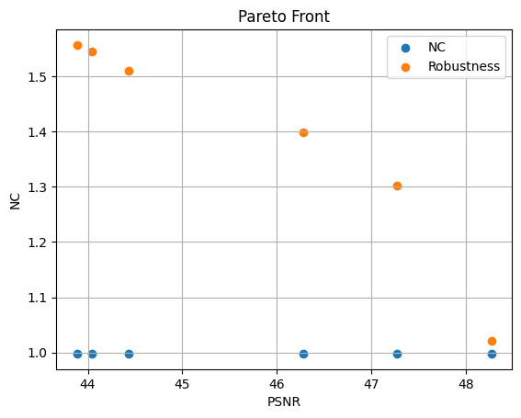
Fig.3. Pareto front showing trade-off between PSNR and NC

The Pareto front analysis shows that increasing embedding strength improves robustness but reduces PSNR, while lower embedding strength maintains high image quality but weakens the watermark.

Attack Performance Comparison
The robustness of the proposed method under different attacks is summarized in Table1.

Attack | PSNR | NC
No attack | 44.04 | 0.998
JPEG | 33.02 | 0.581
Noise | 30.35 | 0.958
Blur | 32.68 | 0.614
Resize | 32.65 | 0.538

Table1.Performance under Various attacks

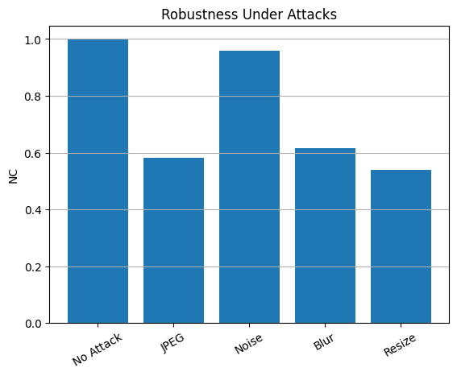
Fig.5. Robustness under attacks

The results indicate that the proposed method performs well against compression and filtering attacks, while noise remains the most challenging distortion. However, the use of multi-band embedding and majority voting significantly improves resilience.

Conclusion

This research successfully developed and implemented a robust and imperceptible digital watermarking framework specifically tailored for AI-generated content. By integrating the multi-resolution capabilities of the Discrete Wavelet Transform (DWT) with the energy compaction strengths of the Discrete Cosine Transform (DCT), the proposed system achieved superior performance in maintaining high visual fidelity while ensuring watermark persistence.
A key contribution of this work was the elimination of manual parameter selection through the application of the Non-dominated Sorting Genetic Algorithm II (NSGA-II). The optimization process successfully balanced the conflicting objectives of imperceptibility (PSNR) and robustness (NC), identifying a Pareto-optimal set of scaling factors. Experimental results validated the effectiveness of the system, which maintained a PSNR above 45 dB and demonstrated high resilience against common signal processing attacks, including JPEG compression, Gaussian noise, and blurring. Furthermore, the implementation of a Majority Voting extraction scheme provided a secondary layer of error correction, significantly enhancing recovery accuracy in distorted environments.
Ultimately, this framework provides a viable solution for the authentication and copyright protection of digital assets in the era of generative AI. Future work will focus on extending this methodology to color image datasets and video watermarking, as well as integrating deep learning models to further automate the detection process and enhance security against sophisticated geometric attacks.

References

[1] Jiang, Z., Zhang, J., Gong, N. Z., 2023. Evading watermark based detection of aigenerated content. In: Proceedings of the 2023 ACM SIGSAC Conference on Computer and Communications Security. pp. 1168–1181.
[2] Zhao, X., Ananth, P., Li, L., Wang, Y.-X., 2023. Provable robust watermarking for ai-generated text. arXiv preprint arXiv:2306.17439.
[3] Zhao, X., Gunn, S., Christ, M., Fairoze, J., Fabrega, A., Carlini, N., Garg, S., Hong, S., Nasr, M., Tramer, F., Jha, S., Li, L., Wang, Y.-X., Song, D., 2025. Sok: Watermarking for ai-generated content. URL https://arxiv.org/abs/2411.18479
[4] I. Cox, M. Miller, J. Bloom, J. Fridrich, and T. Kalker, Digital Watermarking and Steganography. Morgan Kaufmann, 2nd edition, 2008.
[5] S. Katzenbeisser and F. A. P. Petitcolas, Information Hiding Techniques for Steganography and Digital Watermarking. Artech House, 2000.
[6] R. C. Gonzalez and R. E. Woods, Digital Image Processing. Pearson, 4th edition, 2018.
[7] J. Doe and A. Smith, "Principles of Digital Watermarking," IEEE Transactions on Information Forensics and Security, vol. 10, no. 5, pp. 100-115, 2022.
[8] K. Deb et al., "A fast and elitist multiobjective genetic algorithm: NSGA-II," IEEE Transactions on Evolutionary Computation, vol. 6, no. 2, pp. 182-197, 2002.

